[COVER PAGE]

# TABLE OF CONTENTS

TABLE OF CONTENTS 2

EXECUTIVE SUMMARY 4

INTRODUCTION 5

SITE LOCATION 5

STUDY PURPOSE 5

WATERSHED DESCRIPTION 6

DELINEATION 6

SOIL PROPERTIES 8

DESIGN RISK LEVEL 10

DESIGN STORMS 13

X-YR, 24-HR SCS TYPE-2 13

X -YR, 24-HR TXHYETO(50%) 15

X-YR, 6-HR SCS 17

X-YR, 6-HR TXHYETO(50%) 19

HEC-HMS CONCEPTUALIZATION 21

RAINFALL RUNOFF MODEL 23

LOSS MODEL 23

UNIT HYDROGRAPH MODEL 23

HYDROGRAPH ROUTING ELEMENTS 26

CHANNEL ELEMENTS 26

RESERVOIR STORAGE ELEMENTS 28

NORTH RESERVOIR ELEVATION-AREA-STORAGE TABLE 28

WEST RESERVOIR ELEVATION-AREA-STORAGE TABLE 28

US-87 RESERVOIR ELEVATION-AREA-STORAGE TABLE 29

DISCHARGE ESTIMATES 30

PEAK WATER SURFACE ELEVATION 30

EXISTING CONDITION 30

PROPOSED CONDITION 30

INTERPRETATION OF RESULTS 31

SUMMARY, CONCLUSIONS, AND RECOMMENDATIONS 32

REFERENCES 33

APPENDIX-I MANNING’S N VALUES 34

APPENDIX-II HEC-HMS Support Files (Excel Spreadsheets) 35

# LIST OF TABLES

Table 1. CAPTION THE TABLE 7

Table 2. CAPTION THE TABLE 7

Table 3. CAPTION THE TABLE 23

Table 4. CAPTION THE TABLE 25

# LIST OF FIGURES

Figure 1. Location of interest, a multi-barrel culvert system located XXXX of Eden, Texas. 5

Figure 2. Caption The Figure 6

Figure 3. WSS Map of the Study Area. 8

Figure 4. Existing Crossing Configuration 9

Figure 5. Here is the proposed -- you draw the 4-barrel system. 9

Figure 6. CAPTION THE FIGURE 10

Figure 7. CAPTION THE FIGURE 11

Figure 8. CAPTION THE FIGURE 12

Figure 9. X-YR, 24-HR Texas DDF Map. The COLOR shaded area is Concho County, Texas. 13

Figure 10. X-YR, 24-HR SCS Type 2 Design Storm for Concho County, Texas. 14

Figure 11. X-YR, 24-HR TXHYETO-2015.xlsm Design Storm for Concho County, Texas. 15

Figure 12. X-YR, 24-HR Design Storm (HEC-HMS) for Concho County, Texas. 16

Figure 13. X-YR, 6-HR Texas DDF Map. The COLOR shaded area is Concho County, Texas. 17

Figure 14. X-YR, 6-HR SCS Design Storm (HEC-HMS) for Concho County, Texas. 18

Figure 15. X-YR, 24-HR TXHYETO-2015.xlsm Design Storm for Concho County, Texas. 19

Figure 16. X-YR, 24-HR Design Storm (HEC-HMS) for Concho County, Texas. 20

Figure 17. CAPTION THE FIGURE 21

Figure 18. CAPTION THE FIGURE 22

Figure 19. NRCS lag time analysis for West Catchment. 24

Figure 20. NRCS lag time analysis for North Catchment. 24

Figure 21. NRCS lag time analysis for Eden Catchment. 25

Figure 22. Typical Cross Section for <name 1>. 26

Figure 23. Typical Cross Section for <name 2>. 26

Figure 24. Typical Cross Section for <name 3>. 27

Figure 25. CAPTION THE FIGURE 28

Figure 26. CAPTION THE FIGURE 29

# EXECUTIVE SUMMARY

Add Narrative Here – the executive summary is usually written last, however except for results, you can write most of it using the skeleton report here

# INTRODUCTION

Add Narrative Here

## SITE LOCATION

Figure 1 is a map of a portion of Concho County, Texas. In the Southeast corner of the map is Eden, Texas. A US highway runs nearly East-West through Eden and another US highway runs North-South.

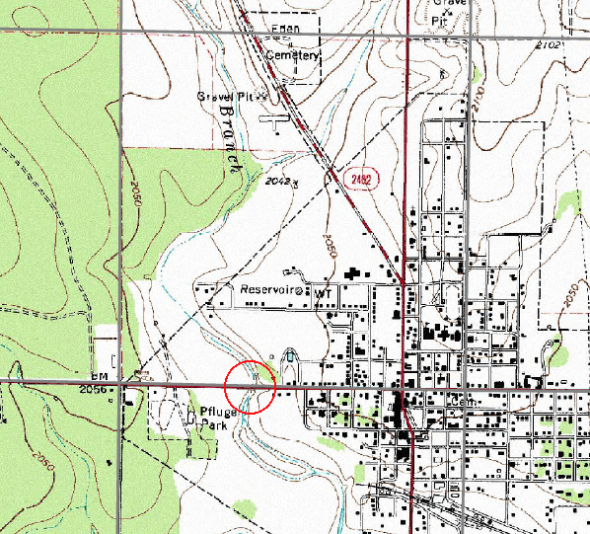

Figure 1. Location of interest, a multi-barrel culvert system located XXXX of Eden, Texas.

## STUDY PURPOSE

The existing culvert system is a 2-barrel 6X6 box-culvert system. This report presents an hydrologic analysis of the existing system at an appropriate risk level to determine the depth of water at the structure (or overtopping depth), and a determination of the depth of flow if the culvert system is modified by the addition of two more barrels to a total of 4-barrel 6X6 box-culvert system.

# WATERSHED DESCRIPTION

<Brief overview of the watershed as it pertains to the study – details are presented in sub-sections that follow>

## DELINEATION

Figure 2 is the watershed that contributes flow to the crossing structure. The total contributing area is XX.X square miles. Two SCS reservoirs regulate flow in the upper reach of the watershed. The sub-areas regulated by these two reservoirs are called the XXXX Catchment, and the XXXX Catchment. The contributing area downstream of both reservoir outlets, but upstream of the point of interest is called the XXXX Catchment.

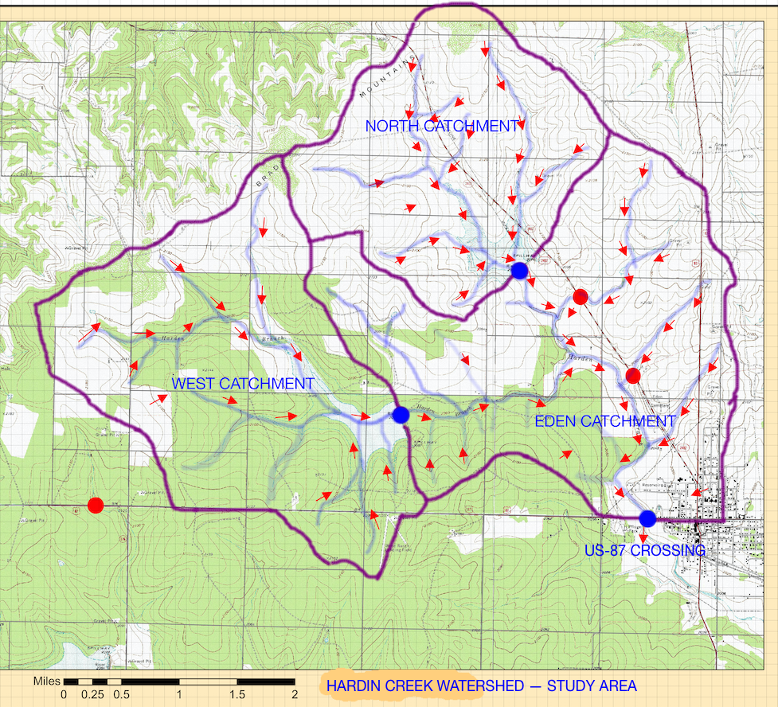

Figure 2. Caption The Figure

<Explain method(s) used to estimate sub-catchment areas>

Table XX is a list of the individual sub-catchment areas as determined by the method above.

Table 1. CAPTION THE TABLE

|  |  |  |
| --- | --- | --- |
| Item | Value | Units |
| XXXX Catchment | XX.XX | Square miles |
| XXXX Catchment | XX.XX | Square miles |
| XXXX Catchment | XX.XX | Square miles |
| Total Drainage Area | XX.XX | Square miles |

The watershed delineation map in Figure 2 was also employed to estimate the travel (channel) distances for each catchment. < Explain method(s) used to estimate channel distances>

These distances are used below to estimate time-of-concentration values to parameterize unit hydrographs for each catchment. Table 2 is a list of the channel length segments for each catchment. For example, the channel length for the West Catchment was estimated to be XX.XX miles. The channel length for the West Catchment to the US-87 crossing was estimated to be XX.XX miles. The methods described above were used to populate Table 2.

Table 2. CAPTION THE TABLE

|  |  |  |
| --- | --- | --- |
| Item | Value | Units |
| XXXX Catchment to Reservoir Outlet | XX.XX | Miles |
| XXXX Catchment to Reservoir Outlet | XX.XX | Miles |
| XXXX Catchment to US 87 Crossing | XX.XX | Miles |
| XXXX Reservoir Outlet to US 87 Crossing | XX.XX | Miles |
| XXXX Reservoir Outlet to US 87 Crossing | XX.XX | Miles |

## SOIL PROPERTIES

Figure 3 is a screen capture of the relevant portion of the Web Soil Survey (CITE) map for the study area.

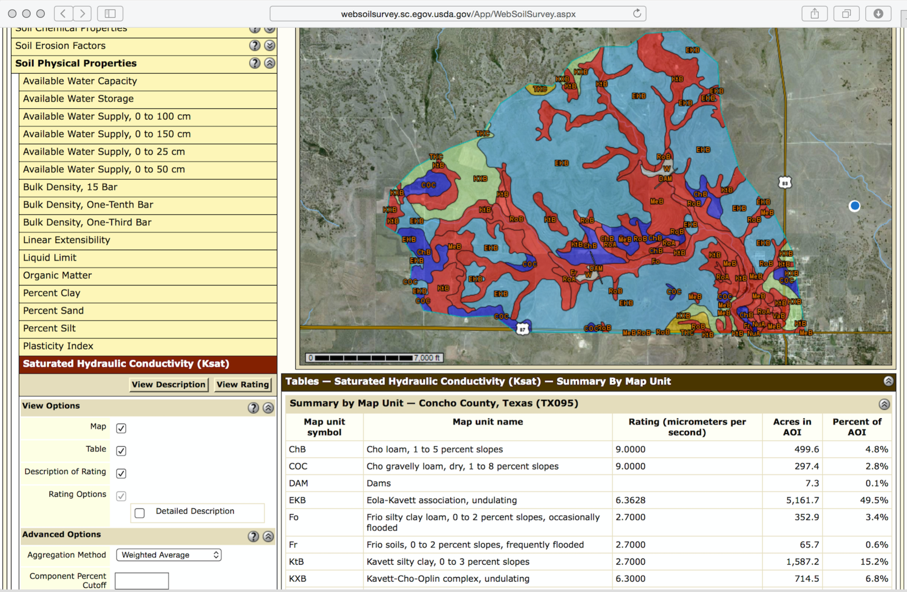

Figure 3. WSS Map of the Study Area.

< Interpet the figure in the context of the study – why do soils matter? >EXISTING CROSSING CONFIGURATION

Describe the existing crossing.

Figure 4 is a sketch

# 

Figure 4. Existing Crossing Configuration

Figure 5 is the proposed.

# 

Figure 5. Here is the proposed -- you draw the 4-barrel system.

Determine and report the bottom (invert) elevation of the culverts – it determines the bottom of the system.HYDROLOGIC ANALYSIS

Brief overview of this section. Details in the following subsections.

## DESIGN RISK LEVEL

The design risk level was determined using Table 4-2 from the TxDOT Hydraulic Design Manual (CITE). The relevant portions of the table are reproduced as Figures 3 and 4.

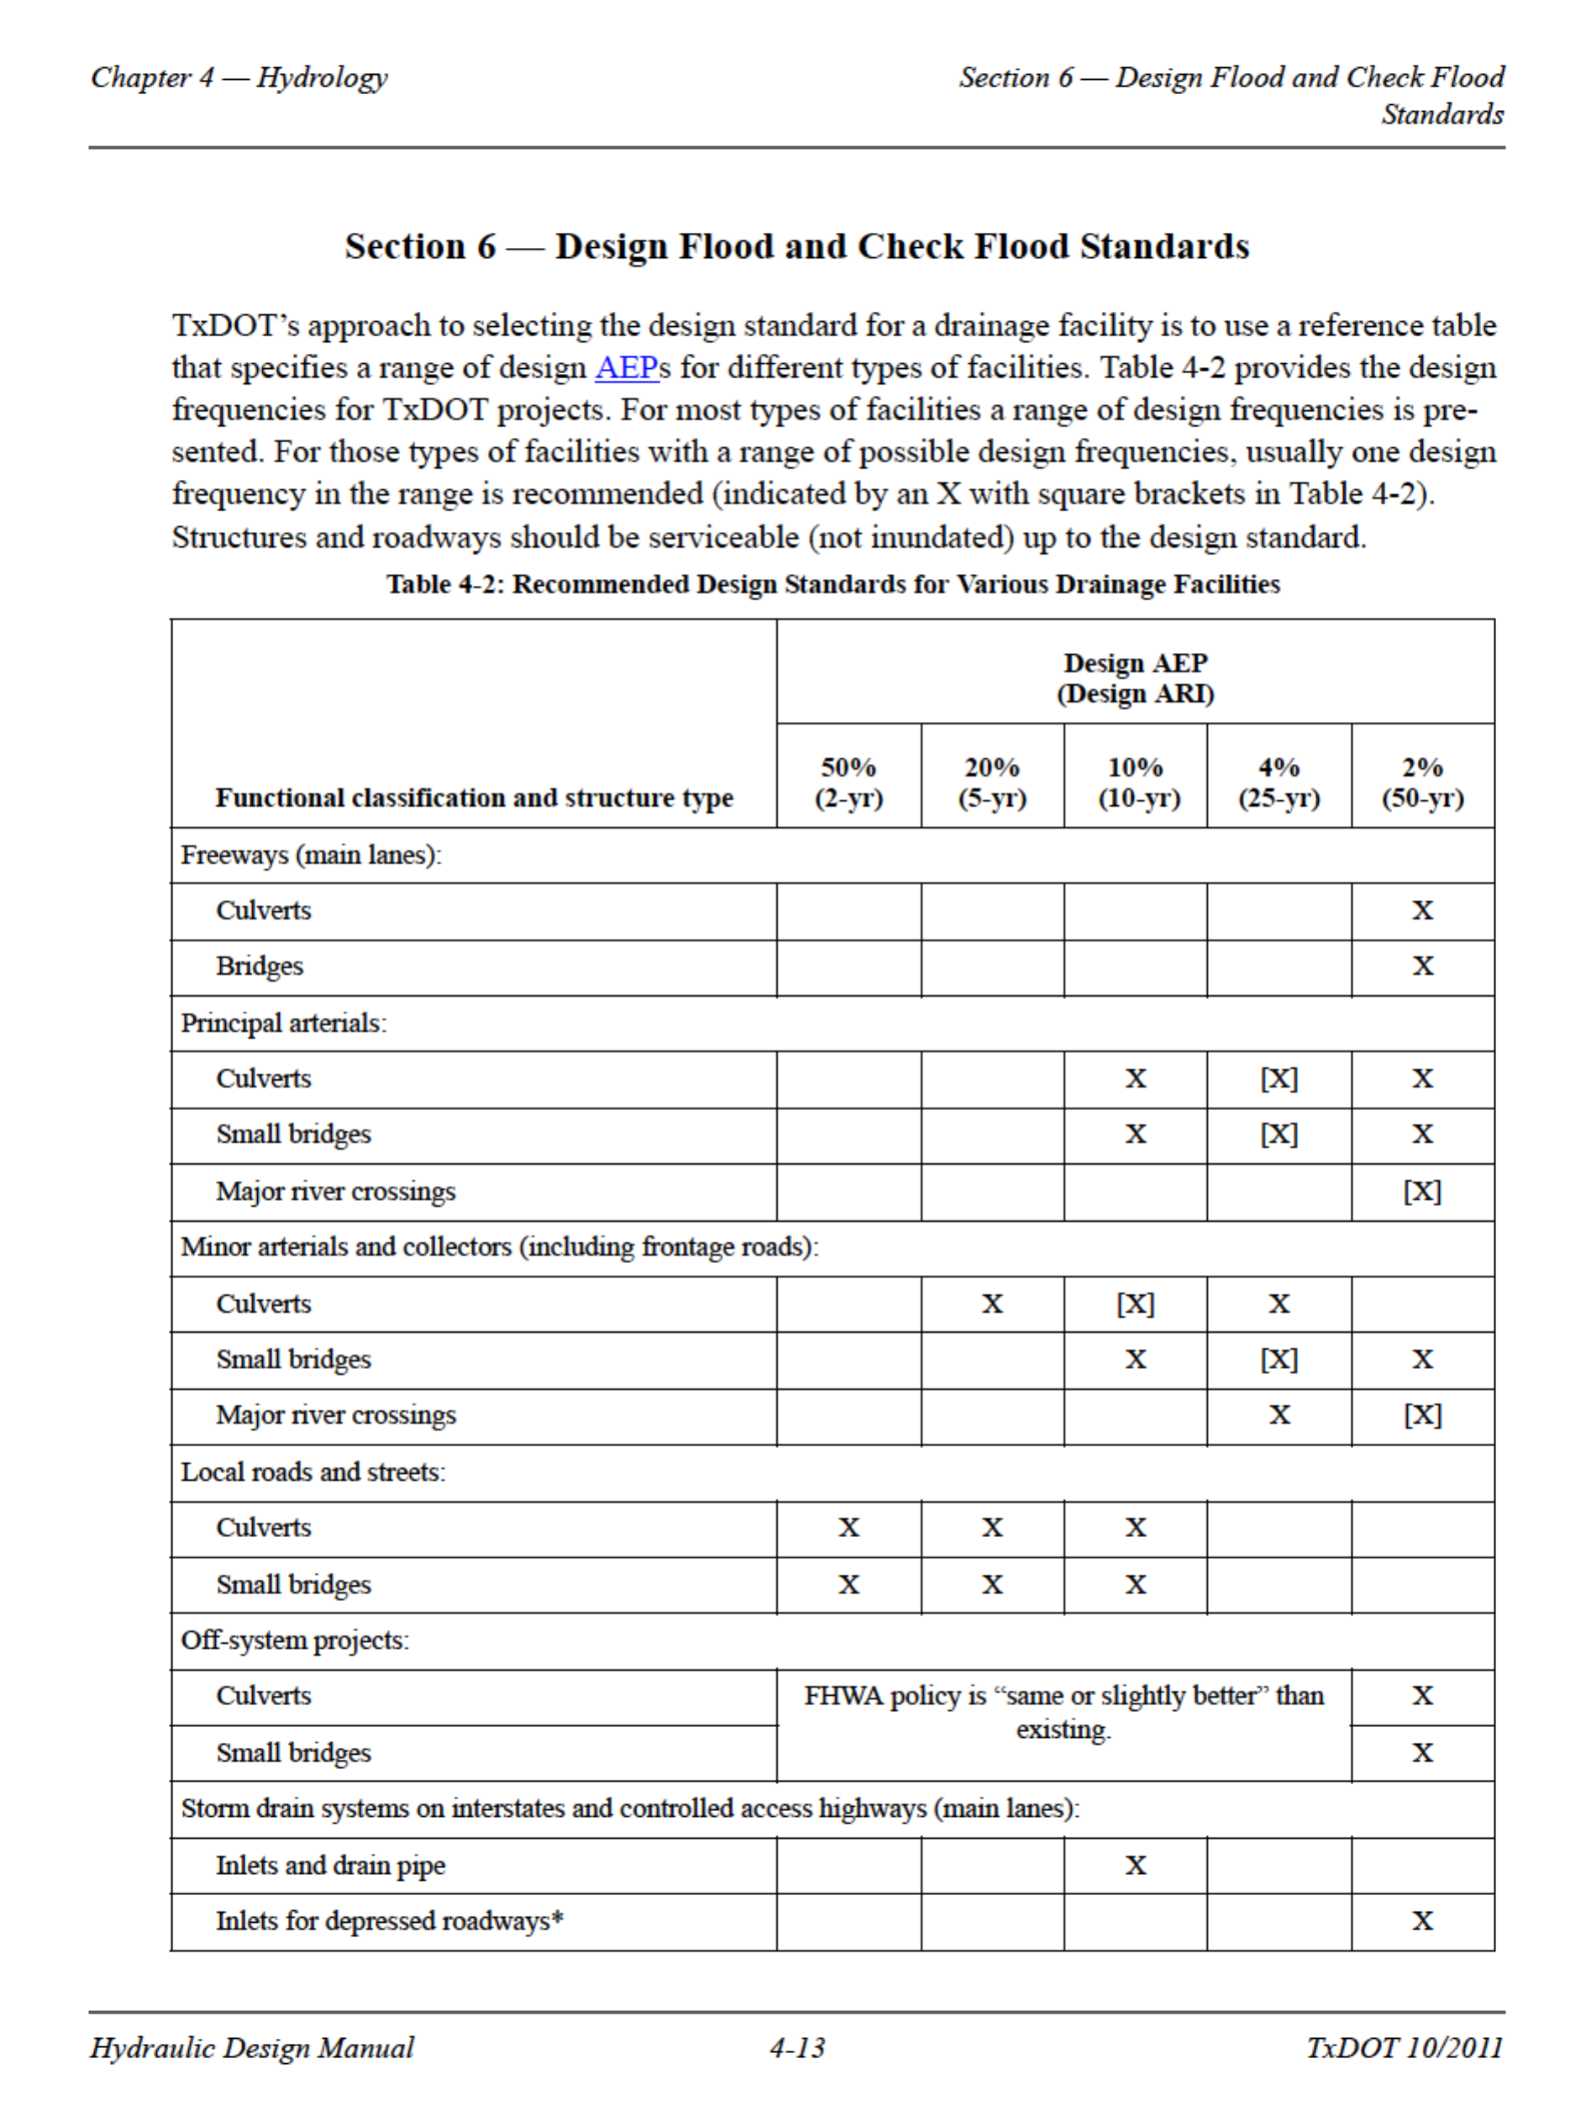

Figure 6. CAPTION THE FIGURE



Figure 7. CAPTION THE FIGURE

<highlight the appropriate rows of the table(s)>

<Justify selection using next tool below>

The functional classification for the structure was determined by using the Statewide Planning Map (CITE), the relevant portion of which is presented in Figure 4.

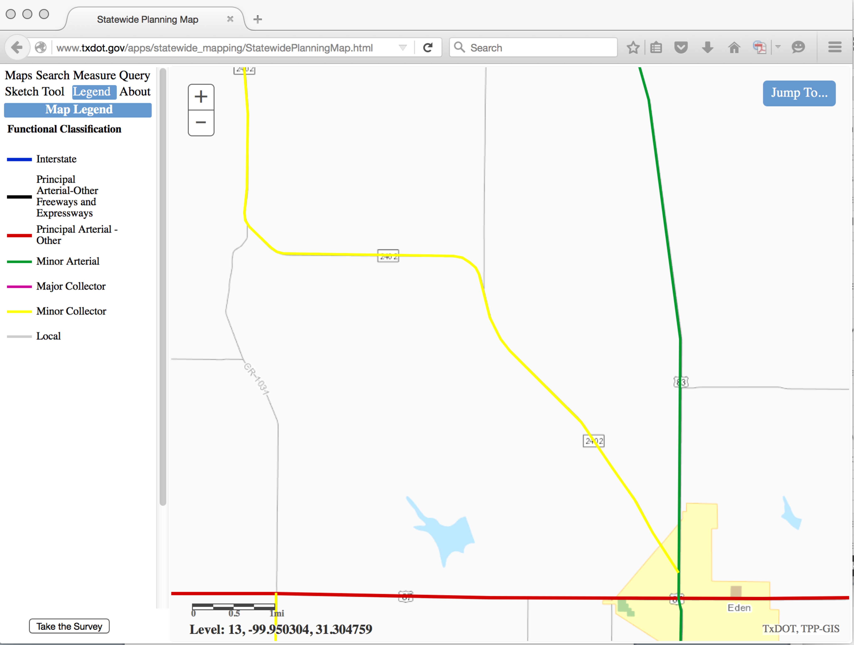

Figure 8. CAPTION THE FIGURE

<summarize and interpret the selection of frequency of interest>

The functional classification at the US-87 crossing location is XXXXXXX. The recommended design frequency (ARI) is XXXX percent (YYY-Year).

## DESIGN STORMS

The risk level determined above were to create several design storms for estimating the hydrologic and hydraulic performance of the US-87 culvert system. Multiple storm types were examined because …. <provide reasoning>

### X-YR, 24-HR SCS TYPE-2

The X-yr, 24-hr SCS Type 2 was selected as one of the design storms to evaluate the US-87 crossing. The total storm depth was determined using the Texas DDF Atlas (CITE) for Concho County. Figure 6 is the relevant map from the DDF Atlas.

Concho county is the COLOR shaded area shown in Figure 6. The X-yr, 24-hr storm depth from the map is XX.X inches.



Figure 9. X-YR, 24-HR Texas DDF Map.   
The COLOR shaded area is Concho County, Texas.

The depth from the Texas DDF map was entered into HEC-HMS to generate an SCS Type 2 Design Storm.



Figure 10. X-YR, 24-HR SCS Type 2 Design Storm for Concho County, Texas.

Figure 7 is a plot of the SCS Storm (from HEC-HMS) for Concho County. The peak discharge rate, in inches-per-hour is XX.X inches/hour. The peak rate occurs at simulation time XX:XX hours.

### X -YR, 24-HR TXHYETO(50%)

The X-yr, 24-hr storm depth from the DDF Atlas was also used to parameterize the Texas Hydrograph. The 50th-percentile dimensionless hyetograph was chosen and parameterized for 15-minute time intervals for use in HEC-HMS as a second design storm to evaluate the performance of the hydraulic structures.



Figure 11. X-YR, 24-HR TXHYETO-2015.xlsm Design Storm for Concho County, Texas.

Figure XX is a screen capture of the design storm based on the TXHYETO-2015.xlsx worksheet for Concho Co., Texas. The peak discharge rate, in inches-per-hour is XX.X inches/hour. The peak rate occurs at simulation time XX:XX hours.

Figure 9 is a screen capture of the actual design hyetograph from HEC-HMS based on the TXHYETO-2015.xlsx tool for Concho, Co., Texas.



Figure 12. X-YR, 24-HR Design Storm (HEC-HMS) for Concho County, Texas.

### X-YR, 6-HR SCS

The X-yr, 6-hr SCS was also examined as one of the design storms to evaluate the US-87 crossing. The total storm depth was determined using the Texas DDF Atlas (CITE) for Concho County. Figure XX is the relevant map from the DDF Atlas. Concho county is the COLOR shaded area shown in Figure XX. The X-yr, 24-hr storm depth from the map is XX.X inches.



Figure 13. X-YR, 6-HR Texas DDF Map.   
The COLOR shaded area is Concho County, Texas.

Because the 6-hr storm is not built into HEC-HMS a spreadsheet was used to generate a user-supplied hyetograph in HEC-HMS. Figure XX is a screen capture of the spreadsheet tool with the 6-hr storm parameterized based upon the value in the DDF Atlas.

Figure XX is a screen capture of the actual hyetograph as it appears in HEC-HMS



Figure 14. X-YR, 6-HR SCS Design Storm (HEC-HMS) for Concho County, Texas.

Figure 7 is a plot of the SCS Storm (from HEC-HMS) for Concho County. The peak discharge rate, in inches-per-hour is XX.X inches/hour. The peak rate occurs at simulation time XX:XX hours.

### X-YR, 6-HR TXHYETO(50%)

The X-yr, 6-hr storm depth from the DDF Atlas was also used to parameterize the Texas Hydrograph. The 50th-percentile dimensionless hyetograph was chosen and parameterized for 15-minute time intervals for use in HEC-HMS as a second design storm to evaluate the performance of the hydraulic structures.



Figure 15. X-YR, 24-HR TXHYETO-2015.xlsm Design Storm for Concho County, Texas.

Figure 12 is a screen capture of the design storm based on the TXHYETO-2015.xlsx worksheet for Concho Co., Texas.

Figure 13 is a screen capture of the actual design hyetograph from HEC-HMS based on the TXHYETO-2015.xlsx tool for Concho, Co., Texas. The peak discharge rate, in inches-per-hour is XX.X inches/hour. The peak rate occurs at simulation time XX:XX hours.



Figure 16. X-YR, 24-HR Design Storm (HEC-HMS) for Concho County, Texas.

# HEC-HMS CONCEPTUALIZATION

Figure 3 is the watershed base map with the HEC-HMS conceptualization overlain on the map. The entire watershed is conceptualized as being comprised of three sub-basins (North Catchment, West Catchment, and the Eden Catchment). The North Catchment drains into the North Reservoir; the West Catchment drains into the West reservoir; and the Eden Catchment drains directly into the US-87 Reservoir.

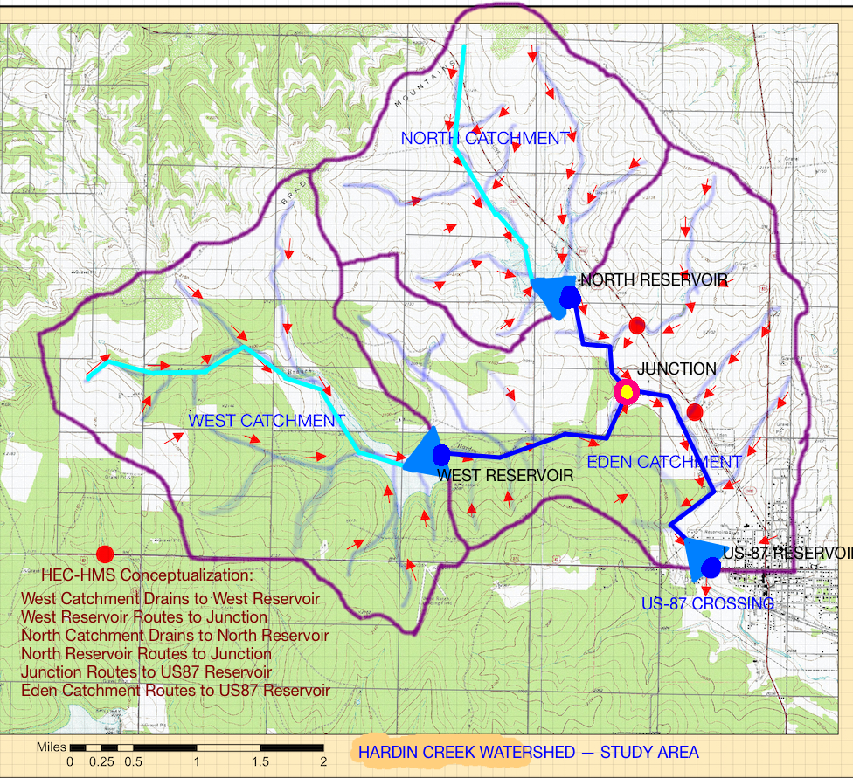

Figure 17. CAPTION THE FIGURE

The discharge from the North and West reservoirs is routed to the Junction depicted on the map. The distances, in feet of these routing elements are: West to Junction is XX.XX feet; North to Junction is XX.XX feet. The distance from the Junction to the US-87 reservoir is XX.XX feet.

Figure 4 is a screen capture of the HEC-HMS interface showing the elements from Figure 3 in the HEC-HMS modeling environment.

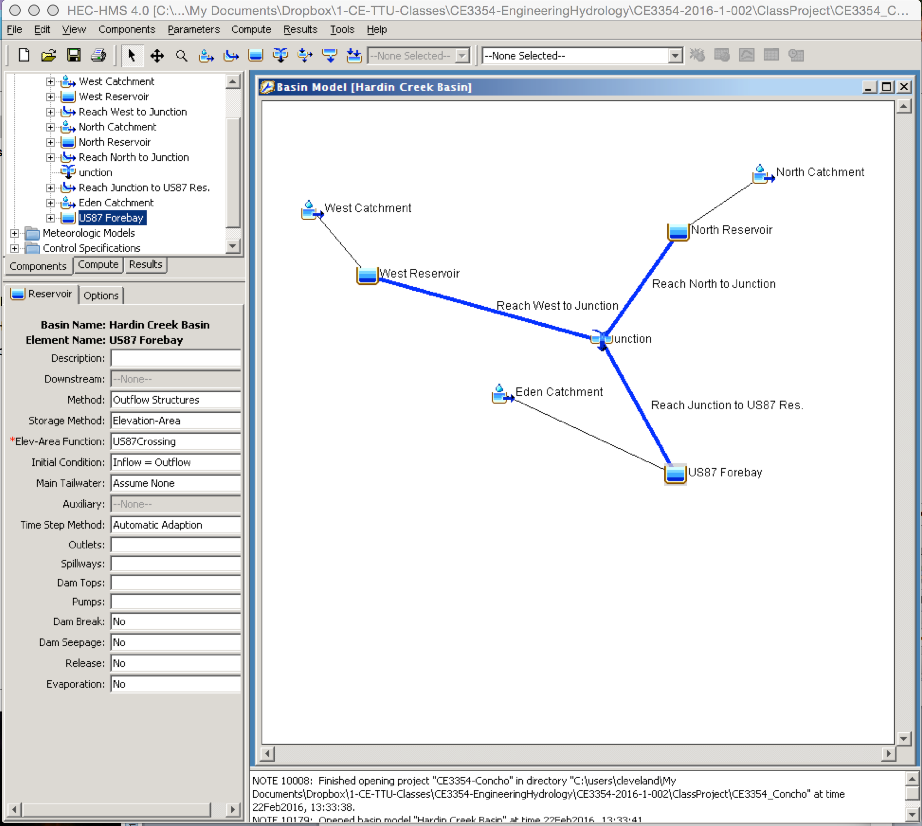

Figure 18. CAPTION THE FIGURE

## RAINFALL RUNOFF MODEL

The rainfall-runoff process selected was the SCS CN loss model, and the lumped parameter transformation model selected was the SCS Dimensionless Unit Hydrograph model. These two models were parameterized using the methods described in the following subsections.

### LOSS MODEL

The SCS CN was determined using the Web Soil Survey results described in the Watershed Description.

<Single example of composite CN calculation for the Eden Catchment (it is only one with any substantial urban area) here>

The composite CN for each sub-basin is listed in Table 3.

Table 3. CAPTION THE TABLE

|  |  |  |
| --- | --- | --- |
| Sub-basin name | Area (sq. mi.) | Composite CN |
| XXXX Catchment |  |  |
| XXXX Catchment |  |  |
| XXXX Catchment |  |  |

### UNIT HYDROGRAPH MODEL

The SCS DUH was parameterized for each sub-basin <list their names here> using the NRCS overland method for different cover types. The <tool name .xlsm> (CITE SOURCE) was used to estimate the travel times for runoff in each of the three catchments.

Figure 16 is a screen capture of the analysis for the West Catchment.



Figure 19. NRCS lag time analysis for West Catchment.

Figure 17 is a screen capture of the analysis for the North Catchment.



Figure 20. NRCS lag time analysis for North Catchment.

Figure 18 is a screen capture of the analysis for the Eden Catchment.



Figure 21. NRCS lag time analysis for Eden Catchment.

Table 4 is a list of ….

Table 4. CAPTION THE TABLE

|  |  |  |
| --- | --- | --- |
| Sub-basin name | Area (sq. mi.) | Lag Time (for DUH) |
| XXXX Catchment |  |  |
| XXXX Catchment |  |  |
| XXXX Catchment |  |  |

## HYDROGRAPH ROUTING ELEMENTS

Discharge leaving the West and North Reservoirs are routed through a stream system to the US-Reservoir.

### CHANNEL ELEMENTS

The channels are modeled as 8-point cross sections and the Muskingum-Cunge routing model is used. The three channel sections are <name the 3 sections>.

Values of Manning’s n appropriate for the channel sections was chosen from Appendix I (Table 8.2 CITE SOURCE).



Figure 22. Typical Cross Section for <name 1>.

Section <name 1> is shown on Figure XX. <describe the channel coverage, grass lined, etc.> Manning’s n for the section is ##. The average channel slope is X.XXXX. The length of the channel is XXXX feet.



Figure 23. Typical Cross Section for <name 2>.

Section <name 2> is shown on Figure XX. <describe the channel coverage, grass lined, etc.> Manning’s n for the section is ##. The average channel slope is X.XXXX. The length of the channel is XXXX feet.



Figure 24. Typical Cross Section for <name 3>.

Section <name 3> is shown on Figure XX. <describe the channel coverage, grass lined, etc.> Manning’s n for the section is ##. The average channel slope is X.XXXX. The length of the channel is XXXX feet.

## RESERVOIR STORAGE ELEMENTS

The West and North Reservoirs are <describe the reservoirs – the dam crest height, the spillway height, and the riser pipe height>

The reservoirs are assumed to already contain water at pool elevation equal to the outlet riser pipe – thus any additional water added to the reservoir will immediately raise the pool elevation above the riser pipe and water will begin to flow out of the reservoir into the drainage channels.

Figure XX is an elevation view (not to scale) sketch of the West and North reservoirs.

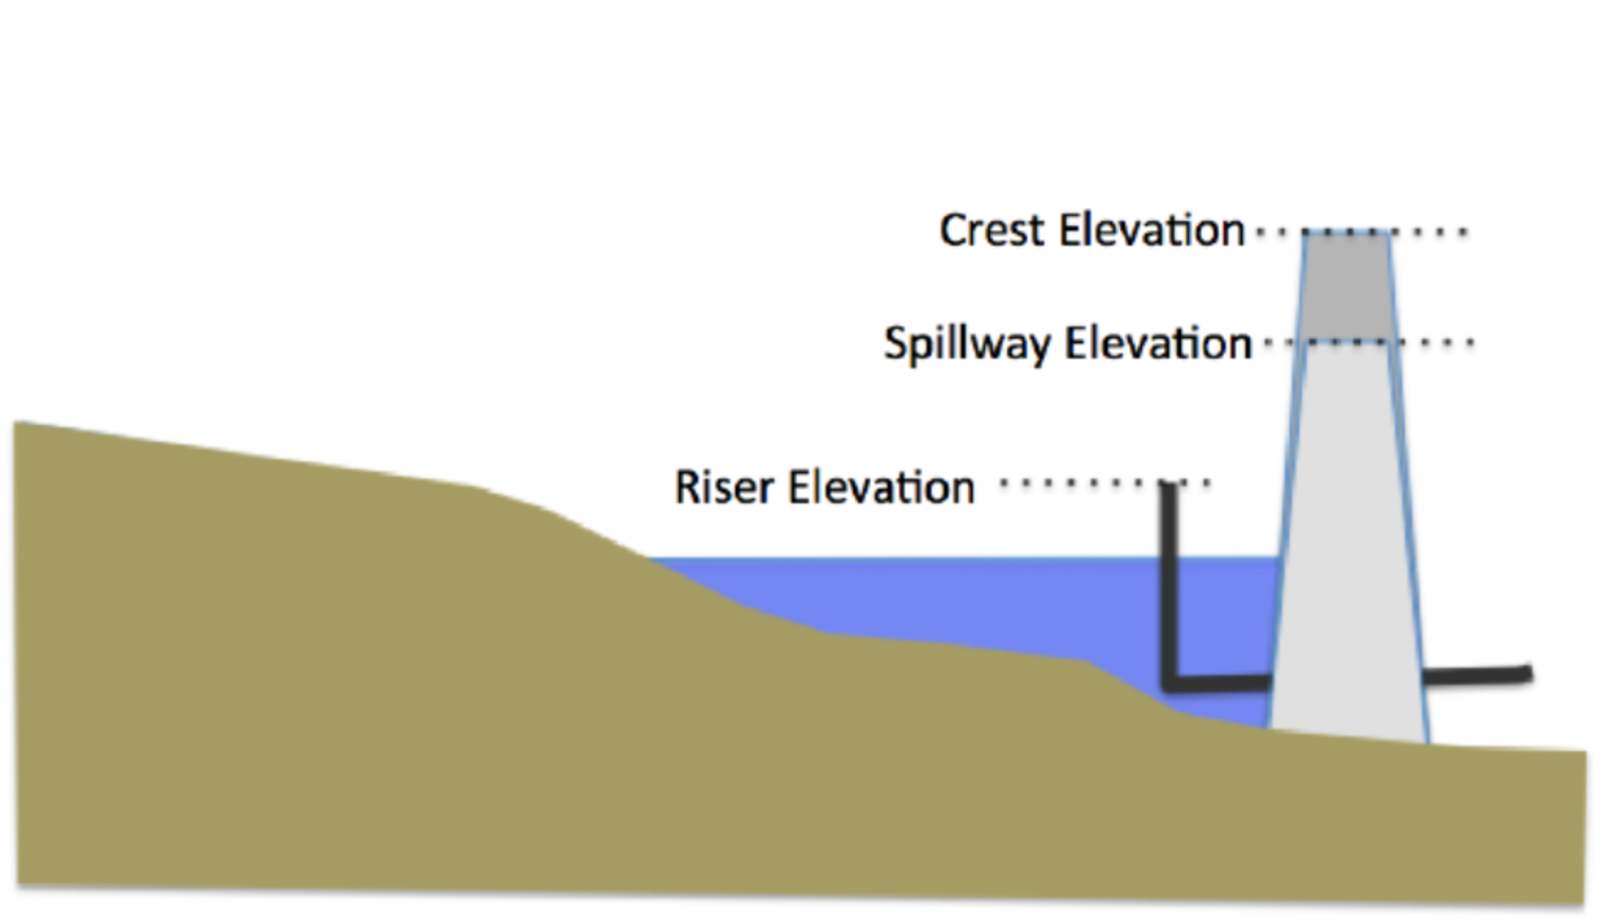

Figure 25. CAPTION THE FIGURE

### NORTH RESERVOIR ELEVATION-AREA-STORAGE TABLE

<describe the elevation-area calculations Lectures 19 and 20>

<Show representative calculations/measurements>

<can assume spillways are 50 ft wide and crest height is 4 feet above spillway>

<report riser elevation, crest elevation, and spillway elevation>

<Then provide the table>

### WEST RESERVOIR ELEVATION-AREA-STORAGE TABLE

<describe the elevation-area calculations Lectures 19 and 20>

<Show representative calculations/measurements>

<can assume spillways are 50 ft wide and crest height is 4 feet above spillway>

<report riser elevation, crest elevation, and spillway elevation>

<Then provide the table>

### US-87 RESERVOIR ELEVATION-AREA-STORAGE TABLE

<Make a similar sketch to Figure 23, except the riser is a horizontal culvert. The spillway elevation is the roadway height>

Figure XX is an profile view looking downstream at the US-87 Crossing (US-87 Reservoir Outlet). The road profile is the grey region that slopes down to the top of the culverts then back up. The original stream channel is shown – there is sufficient space to add additional culvert barrels if indicated. The dashed line approximates the spillway/crest profile (the approximation is for simplicity in hydraulics calculations).

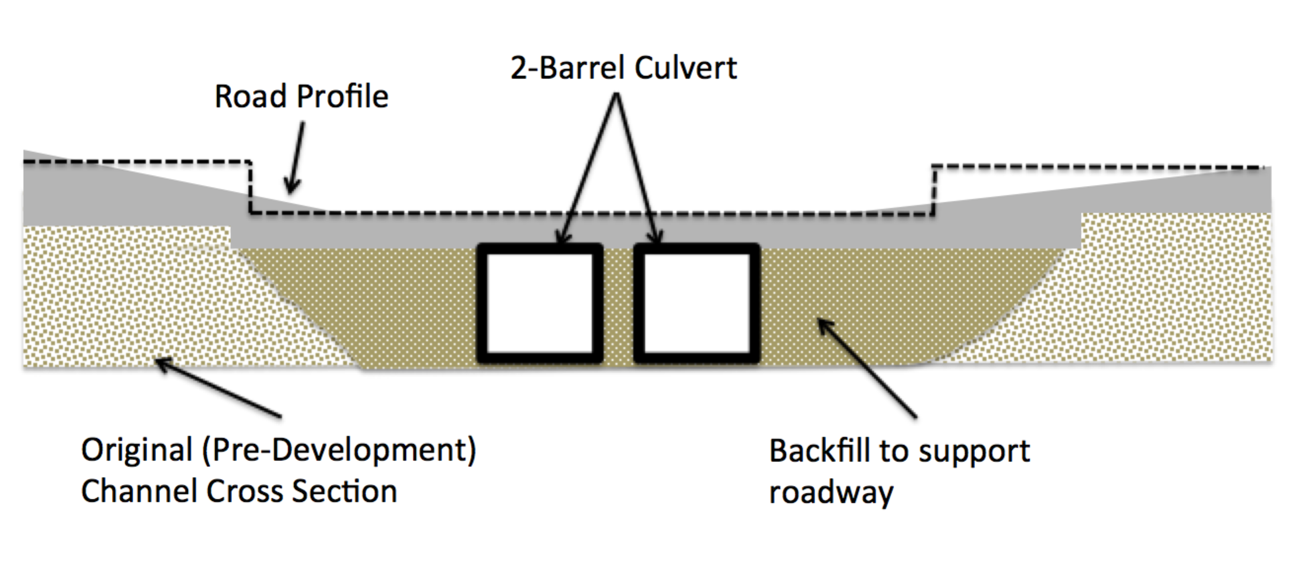

Figure 26. CAPTION THE FIGURE

<describe the elevation-area calculations Lectures 19 and 20>

<Show representative calculations/measurements>

<Use google earth to approximate spillway width and crest height is 0.5 feet above spillway>

<report culvert bottom, crest elevation, and spillway elevation>

<Then provide the table>

## DISCHARGE ESTIMATES

Add Narrative Here – Naturally you need to run the model(s).

## PEAK WATER SURFACE ELEVATION

Add Narrative Here – Naturally you need to run the model(s).

You get peak elevation from where? (which reservoir)

### EXISTING CONDITION

Add Narrative Here – Naturally you need to run the model(s) .

Peak WSE for 4 design storms. Does the reservoir overtop (ie does the elevation go above the spillway?)

### PROPOSED CONDITION

Add Narrative Here – Naturally you need to run the model(s) .

Peak WSE for 4 design storms. Does the reservoir overtop (ie does the elevation go above the spillway?)

# INTERPRETATION OF RESULTS

Add Narrative Here – Naturally you need to run the model(s) .

# SUMMARY, CONCLUSIONS, AND RECOMMENDATIONS

Add Narrative Here – Naturally you have to write this section after nearly everything else is completed.

# REFERENCES

TxDOT 2016. Hydraulic Design Manual, Texas Department of Transportation, (<http://url-goes-here>) accessed date.

Asquith, W.H., and Roussel, M.C., 2004, Atlas of depth-duration frequency of precipitation annual maxima for Texas: U.S. Geological Survey Scientific Investigations Report 2004–5041, 106 p.

Soil Conservation Service, 1973, A method for estimating volume and rate of runoff in small watersheds: Washington, D.C., U.S. Department of Agriculture, Soil Conservation Service, SCS–TP–149, 19 p.

Chow, V.T., Maidment, D.R., and Mays, L.W., 1988, Applied hydrology: New York, McGraw-Hill Publishing Company, 572 p.

HEC-HMS, 2015. Hydrologic Modeling System HEC-HMS. U.S. Army Corps of Engineers, Hydrologic Engineering Center (CEIWR-HEC) (<http://url-goes-here>) accessed date.

Statewide Planning Map – find it cite the URL

NRCS Overland Method – find it, cite the NRCS document. Also cite the URL for the Spreadsheet Tool (if you use it). If you use Kerby-Kirpich, cite the source document (its not my notes!) and the spreadsheet tool if you use it (cite the uRL).

Web Soil Survey – find it; cite the URL.

# APPENDIX-I MANNING’S N VALUES

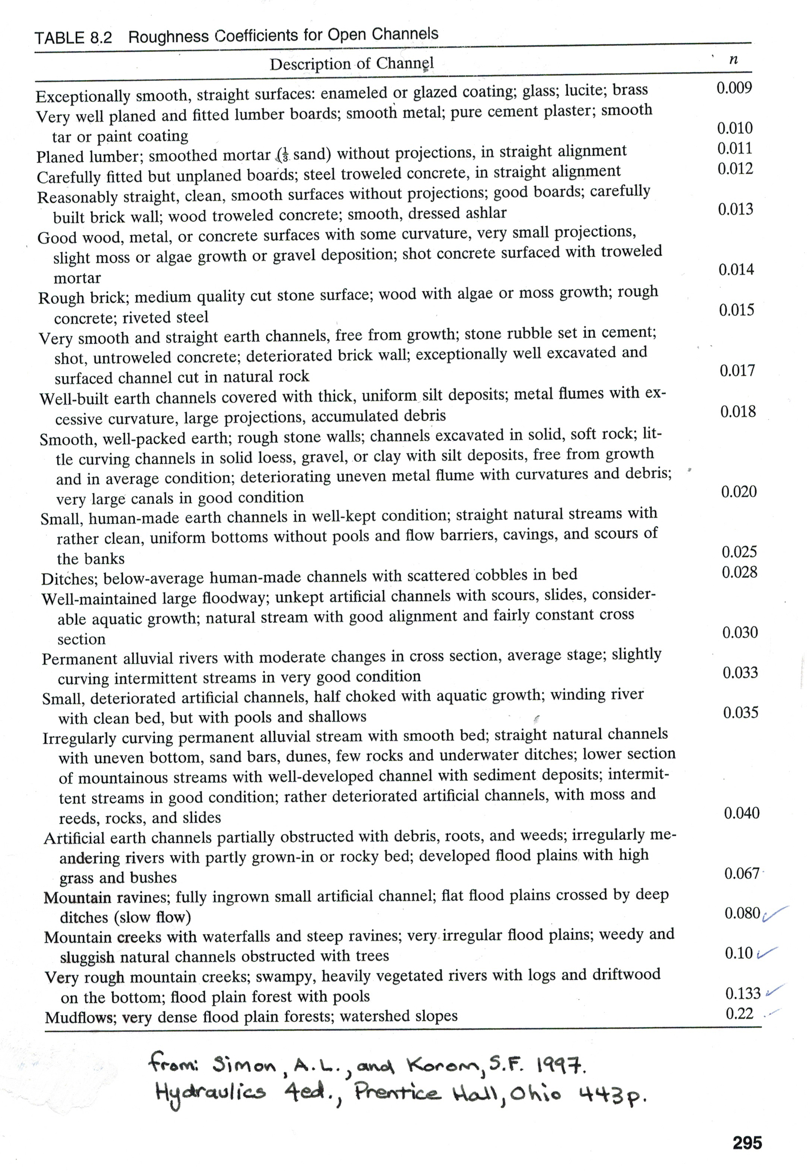

# APPENDIX-II HEC-HMS Support Files (Excel Spreadsheets)